MINOR PROJECT SYNOPSIS

On

HOME RENTAL MANAGEMENT SYSTEM

Submitted as a part of course curriculum for

DIPLOMA



In

INFORMATION TECHNOLOGY(Final Year -Vth Semester)

Submitted By:

Avinash kumar Sandeep kumar verma Aryan Patel

E21220135600022 E21220135600056 E21220135600019

# Aditya Vishwakarma

# E21220135600004

Under the guidance of:

Mr. Sandeep Kumar

(Head Of Department)



DEPARTMENT OF COMPUTER ENGINEERING &

# INFORMATION TECHNOLOGY

(GOVERNMENT POLYTECHNIC LUCKNOW)

UTTAR PRADESH (226016)

Synopsis Report

**RentItQuick.com**

# INTRODUCTION

➢An online Room Rental System will provide the information about Rooms/Flats/Houses/Land which is available for Rent.

➢Room Rental System application will make easy to find the location or Rooms/Flats/Houses, select no. of rooms and other facts by the renter.

➢It will make easy to upload the location, contact NO.

expected rent, No of rooms Facilities and other information by Landlord/room-master.

➢This application will be able to show the rooms/flats/houses with in a particular area selected by user.

## **\*OBJECTIVE\***

➢An online web portal to manage the rental property, facilitate tenants to view all listed property, search for their need using key words such as property type, Type of room (like: Ac or without Ac), Flats, location etc. Landlords need to have provision to post /update their property details with admin approval.

➢Financial inadequacy, such as renting a house when one is unable to purchase, i.e., "renting by necessity". Reducing financial risk due to depreciation and transaction costs, especially for real estate which might be needed only for a short amount of time.

**ABSTRACT :-**

Housing sector remains vigilant to face the challenges of change by employing anew strategy that facilitates easy management of rental houses. Hence there is need to develop arental house management system that can simplify work for the rental managers so that all theirwork can be efficient and effective. The Rental Management System is Searching in Based on theApartment Paying Guest, Office, House in metropolitan cities. The Rental Management System isBased on the Owners and the Customers. The Owner is updated on the Apartment, Office details,House, Paying Guest details. The Customer is details about the Room space, Room rent and theAddress Details also. The Rental Management System is best Suitable the owners because timesave and the only contact and the eligible person and there is no need to explain the room detailson the speak. The Rental Management System is best application in the city place The customercontact and the easily search and the suitable place of Apartment, Office, PG, House and basedthe Money, Limit Person is based on the suitable house.

**Functionalities:-**

Functions of Customer:

* New Registration
* Login Request
* Registration Confirmation by the System
* Reserve House
* House Issued by the System
* Email received for Reserved House.

Functions of System Administrator

* Add Customers/Tenants/landlords
* Send E-Mails for Reserved House
* View Transaction reports
* Post Vacant Houses

Functions of Landlord

* Register in the system
* Post a New house
* Send House Confirmation to System Administrator

**MODULES :-**

LANDLORD REGISTRATION MODULE :-

. This module allows property owners or landlords to register or log in in case the want to post their properties in the system without contacting system administrator to do it

RENTER REGISTRATION MODULE :-

. This module allows Renters to register or log in in case they want to see any house or room in the systems database .

**DATA FLOW DIAGRAM :-**

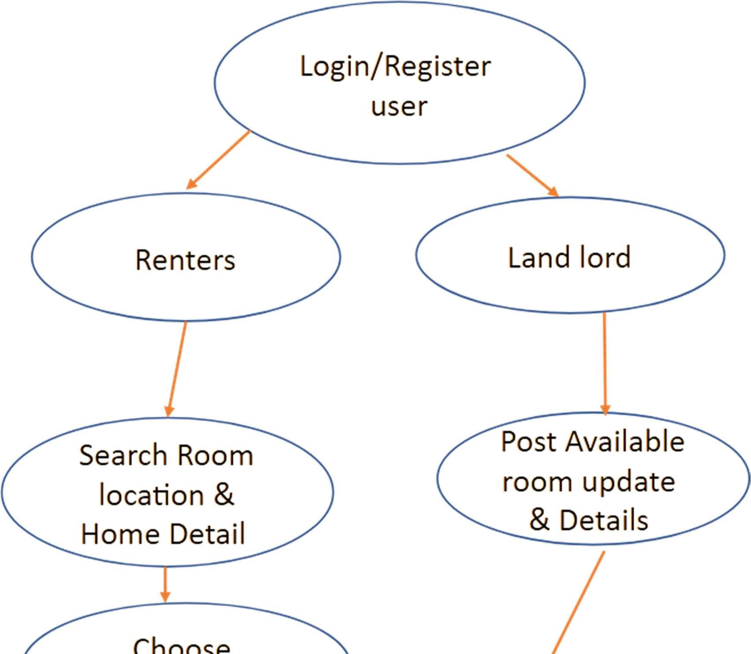

ER DIAGRAM :-

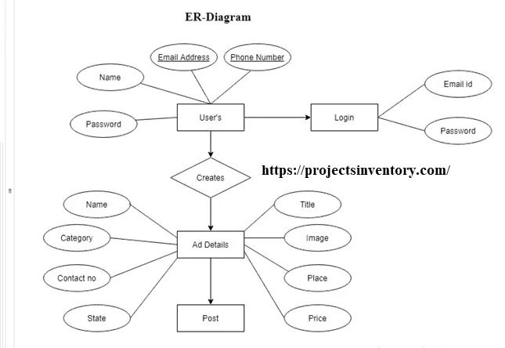

**REQUIREMENTS AND ANALYSIS :**

HARDWARE & SOFTWARE REQUIREMENT:

HARDWARE:

Processor Pentium-II or higher

Processor Speed 533 MHZ

Ram Memory 32 MB (64 MB recommended)

3.1.2 SOFTWARE:

Operating System Windows 95/98/NT/2000 /10/7/8

Database Server MySql /Wamp

Front end html/css/js/bootstrap

Editor VS code / Notepad++

**CONCLUSION :**

ACKNOWLEDGEMENT

We would like to express my special thanks of gratitude to my teacher Er. Rajeev Kumar,

Er. Ashutosh Kumar Singh who gave me the golden opportunity to do this wonderful project on Home Rental Management System, who also helped me to doing a lot of research and I came to know about so many things I am really thankful to them,

Secondly, I would like to thank my friends who helped me to doing this project within the limited time frame.

 SANDEEP KUMAR VERMA,

AVINASH KUMAR

ARYAN PATEL

ADITYA VISHWAKARMA

Diploma in Information

Technology Year- 3rd Year (5th Sem.)

# CERTIFICATE

This is to certify that this report represents the original work done by Sandeep Kumar Verma, Avinash Kumar, Aryan Patel, Aditya Vishwakarma during this project submission as a partial fulfilment of the requirement for the System Design Project in Diploma of Information Technology, of the Government Polytechnic, Lucknow, Uttar Pradesh.

Date-

SANDEEP KUMAR VERMA

AVINASH KUMAR

ARYAN PATEL

## ADITYA VISHWAKARMA

Diploma in Information

Technology Year- 3rd Year (5th Sem.)

## 